JavaScript Objects:

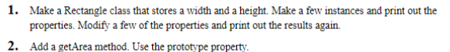

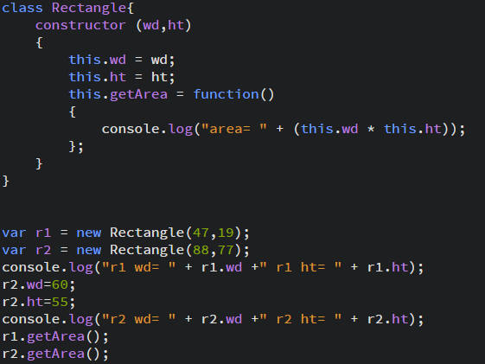







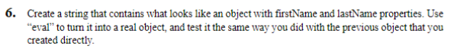







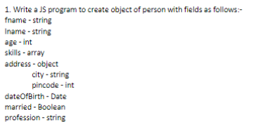





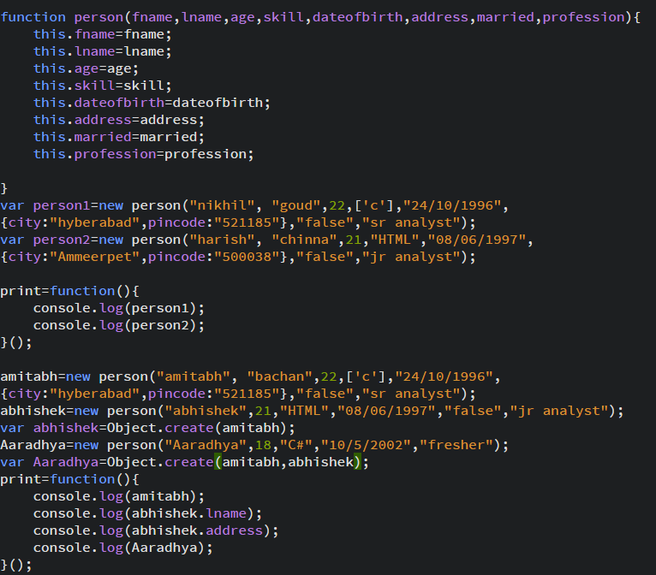



class BankAccount {

constructor(accountNumber, accountHolderName, accountBalance) {

this.accountNumber = accountNumber;

this.accountHolderName = accountHolderName;

this.accountBalance = accountBalance;

this.getCurrentBal = function(){

console.log(this.accountBalance);

};

}

}

class SavingsAccount extends BankAccount {

constructor(accountNumber, accountHolderName, accountBalance, isSalary) {

super(accountNumber, accountHolderName, accountBalance);

this.isSalary = isSalary;

this.withdraw = function(amount){

this.accountBalance -= amount;

if (this.accountBalance< 0){

return -1;

}

};

}

}

class CurrentAccount extends BankAccount {

constructor(accountNumber, accountHolderName, accountBalance, odLimit) {

super(accountNumber, accountHolderName, accountBalance);

this.odLimit = odLimit;

this.withdraw = function(amount){

this.accountBalance -= amount;

if (this.accountBalance < -odLimit){

return -1;

}

};

}

}

var Customer1 = new SavingsAccount(01585566174533, 'Tony Stark', 250000000, true);

Customer1.withdraw(5000);

Customer1.getCurrentBal();

var Customer2 = new CurrentAccount(01585566173224, 'Ivan Vanko', 23, 5000);

Customer2.withdraw(10000);

Customer2.getCurrentBal();